“Why do you take pictures?” It’s a loaded question that I get asked all the time and there’s definitely more than one answer. My first camera was a purple Le Clic that my parents gave me on my 12th birthday. I dangled it from my wrist like a tiny box that held all of my prized possessionsand secrets. That’s what a camera was for me – a diary of sorts that captured everything from my bare feet in the grass to my sister’s favorite toy sitting on her bed to my mother’s briefcase in its usual spot in the dining room. I took pictures because I loved it and at the time it was that simple.

Digital cameras and our smart phones make it easier than ever before to photograph every minute of your life and I still get that question: Why do you take pictures? Because I love it, yes, and because I need it in my daily life. I also love to make lists so here are four more reasons why I’m constantly taking my camera out.

**Because it makes me feel something**

Flowing Water

Moments are fleeting, time passes quickly before your eyes and landscapes are constantly changing. I think that what makes a photograph successful is subjective, but for me, the most important element is that it makes you feel something. What is it about a moment that moves you enough to capture it? A wave will never crash against the shore in the same way, my kids will only have one birthday celebration a year, and the light might never touch a person’s face like that again, and the camera is there to document and preserve that moment so that it can live and move you forever. Beauty and art are everywhere.

**To hold on to memories**

There are days you wish you could hold on to and with your camera, you can. I’m as interested in capturing our mundane routines as I am in capturing holidays and special events. Since I had my kids I feel acutely aware of how quickly time goes and in our increasingly busy lives it’s difficult to always be in the moment. Taking pictures helps you to hang on to those memories a little longer. Hardly anyone (except me, it seems) makes photo albums anymore but remember how you felt and how your smile spread across your face when you would hold those prints in your hand? We’re looking at pictures on our screens more than ever but the feeling of wanting to hold on to memories is still the same.

**To learn to see**

Our eyes can only see so much and teaching yourself how to use them (and to actually look) is a skill you can practice. Take your

[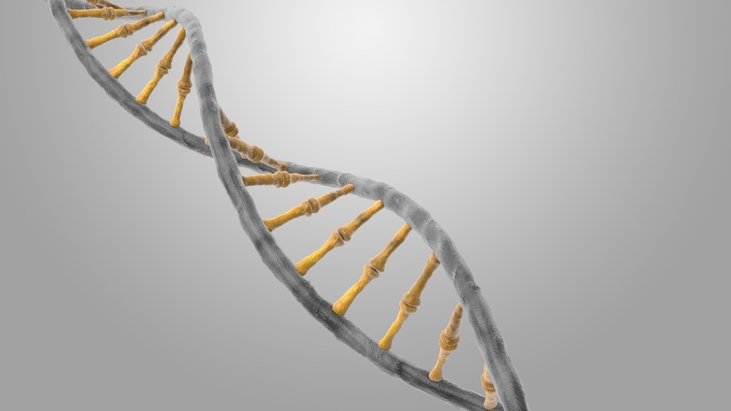](https://www.google.com/search?q=image&client=firefox-b&tbm=isch&tbo=u&source=univ&sa=X&ved=0ahUKEwj3seez_bXOAhXLLY8KHZToBiEQsAQIJQ&biw=1696&bih=807#imgrc=4RQmYxj5K8P1TM%3A)DNA

camera with you and use it. Some moments happen quickly but if you’ve trained your eye to see and capture, then you can keep up. I’m trying to look at everything and I’m getting better at seeing in the process.

**To tell a story**

There are images that can transport you to a different time and place. I love being able to express myself through my camera and use it as an extension of myself to tell stories that people want to hear and that I want to remember. Take your camera (or phone) and take photos of everything from your lunch to the changing leaves of the season to your vacation to your family and friends. These are the images that tell your story.